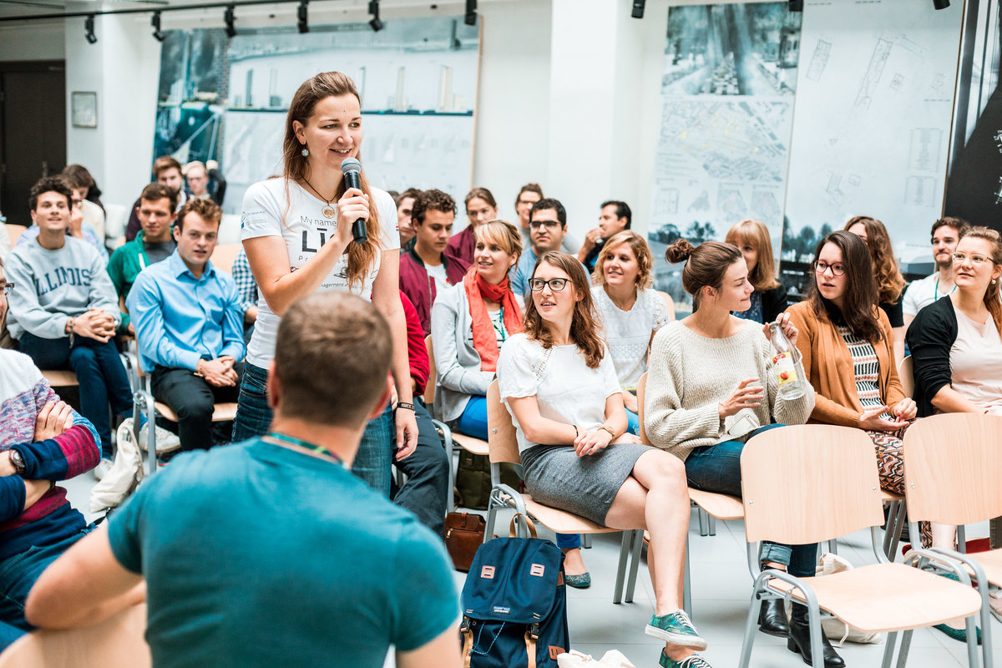

Do you envision a sustainable future? Do you want to use your skills to improve our climate? At the world’s largest climate innovation summer school the Journey, you can learn how the systems innovation approach works to create positive impact and achieve your dream of a sustainable future. Apply now! bit.ly/journey2020applynow

